PROJECT POSTMORTEM
Google Stadia
Cloud gaming platform, March 2019 – January 2023

Author | Anas Altaf
Course | CIS 4374 / TLIM 3355, Dr. Otto Dobretsberger
Date | November 2026
Format | Blameless postmortem: focuses on decisions and conditions, not individuals

~3.8 yrs  Announcement to shutdown | ~150  Studio staff affected (2021) | 22  Games at launch | 100%  Purchases refunded

1. Summary
Google Stadia was a cloud gaming service that streamed games from Google's data centers to TVs, computers, and phones, removing the need for a console or gaming PC. It was announced in March 2019, launched in November 2019, and shut down on January 18, 2023, after Google concluded it "hasn't gained the traction with users that we expected."
The technology largely worked. The project failed on product strategy: it launched with a small game library, asked players to pay a subscription and full game prices to rebuild their libraries on a new platform, missed promised features at launch, and then reversed its content strategy within 15 months. Without enough players, publishers had little reason to bring games, and without games, players had little reason to come.

2. Background and objectives
Google's stated goal was to make high-end games playable instantly on any screen, using its global data-center network. Players would buy games through the Stadia store and, with the Pro subscription, stream in up to 4K. Google also built first-party studios, Stadia Games & Entertainment, led by industry veteran Jade Raymond, to create exclusive games.
- Implied objective: Attract a large base of players without consoles or gaming PCs.
- Implied objective: Convince publishers to bring major (AAA) titles to the platform.
- Implied objective: Build exclusive first-party content to differentiate Stadia.

3. Timeline
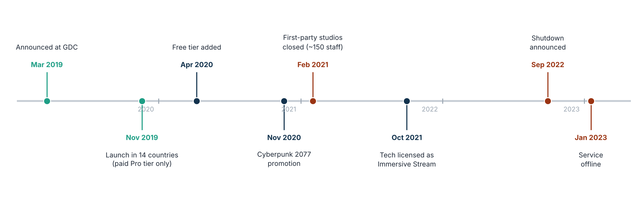
Figure 1. Key events in Stadia's life cycle.
Date | Event
Mar 19, 2019 | Stadia announced at Google's GDC keynote as a cloud gaming platform playable on any screen with no console.
Nov 19, 2019 | Launch in 14 countries. Only the paid Pro tier (about $10 per month) was available, sold with a $129 Premiere Edition bundle (controller and Chromecast Ultra). Players also bought each game at full price.
Nov 2019 | Google confirms features missing at launch, including achievements, family sharing, and several promised social features (State Share, Crowd Play).
Apr 8, 2020 | Free tier launched, with two months of Pro free for new users.
Nov 19, 2020 | Cyberpunk 2077 promotion bundles free hardware with the game; the game runs better on Stadia than on last-generation consoles.
Feb 1, 2021 | Google closes Stadia Games & Entertainment, its first-party studios. About 150 staff are affected and studio head Jade Raymond leaves. Five days earlier, internal teams had been told they had made "great progress."
Feb 2021 | Bloomberg and Wired report that Stadia missed its user and revenue targets by a significant margin.
Oct 2021 | Google begins licensing the streaming technology to other companies as "Immersive Stream for Games."
Sep 29, 2022 | Google announces Stadia will shut down, saying it "hasn't gained the traction with users that we expected." All hardware and game purchases are refunded.
Jan 18, 2023 | Stadia goes offline. A tool to switch controllers to Bluetooth is released the day before.
Table 1. Detailed timeline.

4. Impact
- Players: players lost access to their game libraries, although all hardware and game purchases were refunded.
- Developers and staff: about 150 studio staff were affected by the 2021 studio closure, and developers who had ported games lost a sales channel.
- Google: Google lost its investment in hardware, studios, and content and paid for refunds of all hardware and game purchases. The UK Competition and Markets Authority estimated Stadia's share of the global cloud gaming market at 5–10% in 2021, falling to 0–5% in 2022.
- Reputation: the failure reinforced a perception that Google products may be discontinued, which can make customers and partners hesitant to commit to new Google platforms.

5. Root cause analysis
Applying the "five whys" to the outcome shows a chain of causes rather than a single failure:
- Why? Stadia shut down because it did not have enough paying users.
- Why? Players did not join because the library was small and they had to rebuy games they already owned.
- Why? The library stayed small because publishers saw too few users to justify porting costs.
- Why? Google's own exclusives, meant to break this cycle, were cancelled after 15 months.
- Root cause: the business model and launch plan assumed that strong technology would attract both sides of the platform, without a funded plan to solve the content problem first.

Cause | What happened | Severity
Content and network effects | Players choose a platform for its game library and for where their friends play. Stadia started with 22 games and never gained the catalogs of Xbox, PlayStation, or Steam. Games bought elsewhere could not be played on Stadia, so every player had to rebuy their library. | Critical
Business model | Charging a subscription and full game prices at the same time asked players to pay twice for a new platform with fewer games. The free tier arrived five months after launch, after first impressions had formed. | Critical
Developer economics | Publishers had to port games to Stadia's Linux-based platform for a small user base. Google offered to fund some porting, but competitors that streamed games players already owned were easier for developers to support. | High
Launch readiness | Promised features were missing at launch, and early reviews focused on what Stadia could not do yet. The launch was timed to a date rather than to a ready product. | High
Strategy reversal and trust | Google closed its first-party studios after about 15 months, shortly after reassuring staff. Combined with Google's history of discontinuing products, this signaled to players and developers that the platform might not last. | High
Weak value proposition for the target user | The players most interested in AAA games already owned consoles or gaming PCs. Players without them were less likely to pay for AAA games, and the service needed a fast, stable internet connection. | Medium
Table 2. Contributing causes.

6. What went well
- The core streaming technology worked on good connections, and some games, such as Cyberpunk 2077, ran better on Stadia than on last-generation consoles.
- Instant play with no downloads, installs, or patches.
- The shutdown itself was handled well: Google refunded all hardware and game purchases and released a tool so controllers could keep working over Bluetooth.
- The technology was reused through white-label licensing and other Google products.

7. Lessons learned
Lesson | Explanation
Solve the supply side first | A platform with two sides (players and games) fails if one side is missing. Secure the content, partners, or inventory before asking users to commit.
Lower the cost of switching | Ask what users must give up to adopt the product. Stadia asked players to rebuy games they already owned; competitors that streamed existing libraries avoided this.
Match the pricing to the value at launch | Lead with the lowest-friction entry point (free tier, trial) when the product is new and its value is unproven.
Launch when ready, not on a date | Missing features at launch shape reviews and word of mouth for years. Cut scope deliberately and communicate it, rather than promising and missing.
Commit visibly, or say how long you will commit | Partners and customers invest based on whether the platform will last. Sudden reversals destroy that trust and are hard to recover from.
Communicate honestly with the team | Telling staff their progress was great days before closing their studios damaged trust inside and outside the company.
Table 3. Lessons learned.

8. Recommendations for future projects
# | Recommendation
R1 | Validate demand and willingness to pay with the target segment before the build, not after launch.
R2 | Set explicit success metrics (users, retention, catalog size) with decision dates, and review them openly at each stage gate.
R3 | Plan launch scope with a minimum set of must-have features; slip the date rather than launch without them.
R4 | For platform products, budget for the supply side (content, partners, inventory) as a core cost of the project, not a later add-on.
R5 | Write the exit plan early: refunds, data, and device support, so that if the product is retired, customers are treated fairly.
Table 4. Recommendations.

9. Relevance to the Smart Parking Platform
Stadia's failure has direct lessons for our semester project, which is also a two-sided platform:
Stadia lesson | How it applies to our project
Two-sided platform | Stadia needed games before players would come; the Smart Parking Platform needs parking inventory (facilities) before drivers will use it. This is why the plan includes a pilot facility target and operator engagement (risks P-04 and T-02).
Switching cost | Drivers already use other parking apps. Upfront, all-inclusive pricing and a single app for search, booking, and navigation are the plan's answer to "why switch?"
Launch readiness | The plan protects go-live with MoSCoW priorities and defers Could-have items, rather than launching with promised features missing.
Table 5. Parallels between Stadia and the Smart Parking Platform.

Sources
- Den of Geek. Why Google Stadia failed and is finally shutting down (Sept 30, 2022). https://www.denofgeek.com/games/why-google-stadia-failed-shut-down-explained/
- PC Gamer. Stadia's death spiral, according to the Google employee in charge of mopping up after its murder (Sept 19, 2023). https://www.pcgamer.com/stadias-death-spiral-according-to-the-google-employee-in-charge-of-mopping-up-after-its-murder
- PC Gamer. Report: Google told Stadia developers progress was great, began layoffs five days later (Feb 17, 2021). https://www.pcgamer.com/uk/report-google-told-stadia-developers-progress-was-great-began-layoffs-five-days-later
- 9to5Google. Google shuts down first-party Stadia Games & Entertainment (Feb 1, 2021). https://9to5google.com/2021/02/01/google-shuts-down-first-party-stadia-games-entertainment/
- Gematsu. Stadia to shut down on January 18, 2023; all purchases to be refunded (Sept 29, 2022). https://www.gematsu.com/2022/09/stadia-to-shut-down-on-january-18-2023-all-purchases-to-be-refunded
- Engadget. Google demos Stadia UI and lists several missing launch features (Nov 14, 2019). https://www.engadget.com/2019-11-14-google-demos-stadia-ui-and-lists-several-missing-launch-features.html
- Liliputing. Google Stadia launches this week with 22 games (Nov 2019). https://liliputing.com/2019/11/google-stadia-launches-this-week-with-22-games-you-can-play-without-a-console-or-gaming-pc.html
- Wikipedia. Google Stadia. https://en.wikipedia.org/wiki/Google_Stadia

